IPL Player Performance Prediction

Abstract

This project aims to predict the performance of IPL batsmen using historical match data and machine learning techniques. The datasets were collected from Kaggle and include ball-by-ball delivery data and match-level information. The raw data was converted into a player–match level dataset. Several performance-based features such as recent form, strike rate and career average were engineered to represent the consistency and form of players. A machine learning model was trained to predict the number of runs scored by a batsman in a match. SHAP was used to explain the predictions and identify the most influential features. An interactive Streamlit dashboard was developed to allow users to select a player and view predictions, recent performance and explanation of the model output. This project demonstrates how machine learning and data analytics can be applied effectively in sports analytics.

Introduction
Cricket has become a highly data-driven sport in recent years. Large volumes of match data are generated for every delivery in professional leagues such as the Indian Premier League (IPL). Analyzing this data helps teams, analysts and fans understand player performance and match outcomes more effectively.
Traditional performance analysis mainly depends on simple statistics such as total runs or averages. However, these methods do not fully capture a player’s recent form and performance trends. Machine learning techniques can learn patterns from historical data and provide better predictive insights.
This project focuses on building a machine learning based system to predict the number of runs a batsman may score in an IPL match using historical player performance data.

Objectives
• To collect IPL match data from publicly available sources
• To create a player-match level dataset from ball-by-ball data
• To perform feature engineering for capturing player form and consistency
• To build a machine learning model for predicting batsman runs
• To explain the model predictions using SHAP
• To develop an interactive web dashboard for prediction and visualization

Dataset Description
The datasets used in this project were obtained from Kaggle.
Two main datasets were used:

deliveries.csv
This dataset contains ball-by-ball information of IPL matches.
Important columns include:
- match_id
- batter
- bowler
- batsman_runs
- total_runs
- dismissal_kind

matches.csv
This dataset contains match-level information.
Important columns include:
- id
- season
- venue
- teams
- winner
- toss decision
These two datasets were combined during the data preparation stage.

Methodology

The overall workflow of the project consists of the following stages:



Week 1 - Data Exploration

In the first stage, the datasets were loaded using pandas.
The following tasks were performed:
- Checked the shape and structure of the datasets
- Displayed column information and data types
- Identified missing values
- Performed exploratory data analysis
- Created visualizations such as:
matches per season
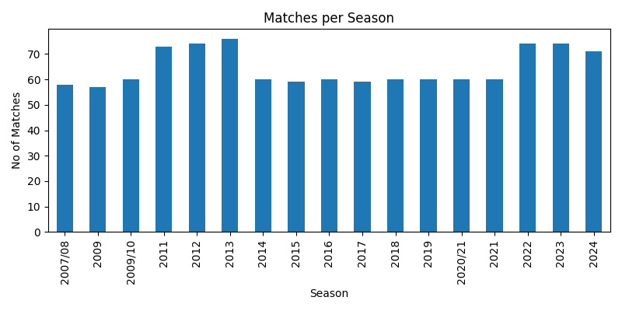
top venues
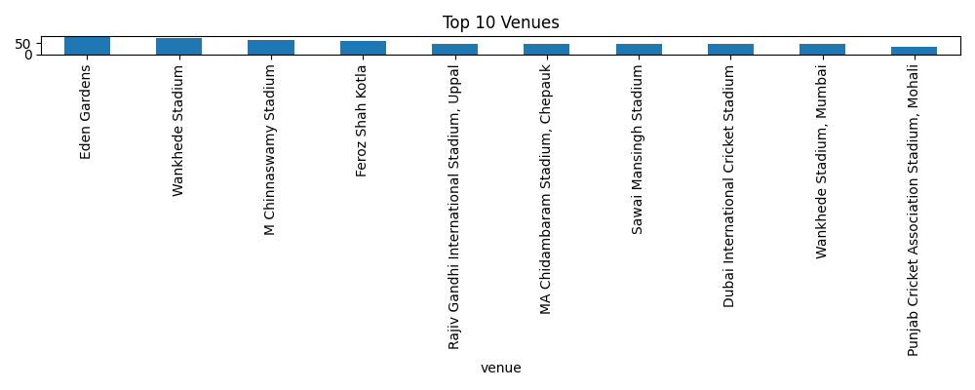

toss decision distribution
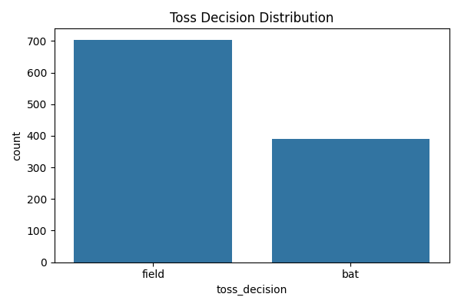
top batsmen by total runs
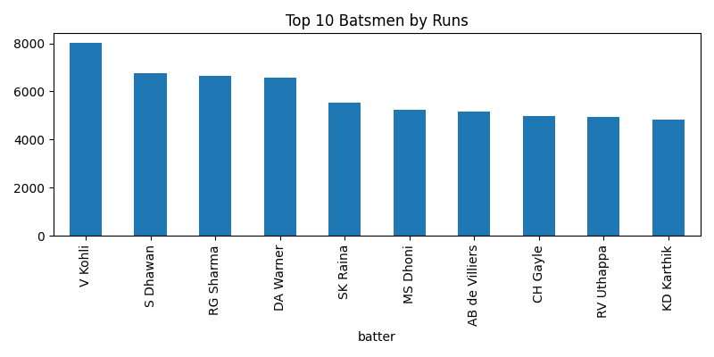top bowlers by wickets
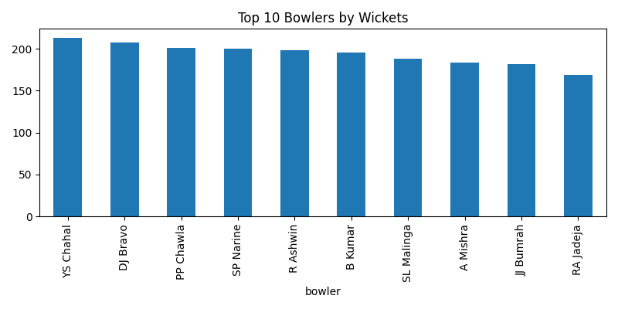
runs per ball distribution
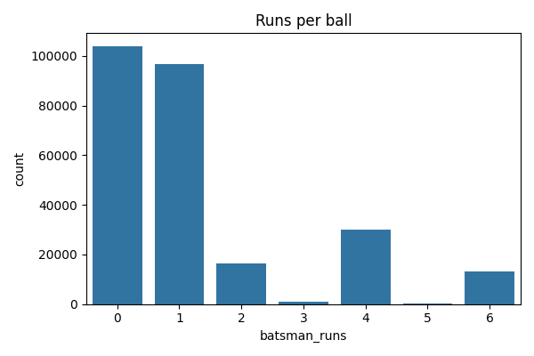This step helped in understanding the data quality and overall trends in the IPL datase

Week 2 - 1. Data Preparation
The ball-by-ball deliveries data was merged with the matches dataset using the match id.
Only the required columns were selected for further processing.
The merged data was then aggregated to create a player–match level dataset using the following grouping:
- season
- match_id
- batter
For each player and match, the following were computed:
- total runs scored
- total balls faced
This resulted in a new dataset called player_match_level.csv.

- Feature Engineering
To capture player form and consistency, several features were created.
The engineered features include:
- Strike rate
- Number of matches played till the current match
- Career average runs till the previous match
- Average runs in the last 5 matches
- Average strike rate in the last 5 matches
Rolling and cumulative operations were used to ensure that only past information was used for creating features.
Rows with missing feature values were removed to create the final feature dataset.
The final dataset was saved as batsman_features.csv.

Week 3 – Model Development
In this week, the prepared and engineered dataset was used to build the initial machine learning models.
The final feature dataset created in the previous stage was loaded and separated into:
- input features
- target variable (runs scored by the batsman)
The dataset was then split into training and testing sets to evaluate the generalization capability of the models.
The objective of this week was to establish a baseline learning setup and prepare the data pipeline required for model training. Only numerical performance-based features were used so that the model learns patterns purely from player performance history.
The following tasks were carried out:
- selection of relevant input features
- separation of target variable
- train–test split of the dataset
- preparation of data for different regression models

This stage ensured that the dataset was clean, consistent and suitable for machine learning algorithms.

Week 4 – Feature Analysis and Understanding
In this week, the engineered features were analyzed to understand their distributions and relationships with the target variable.
Several visualizations were created to study:
distribution of runs scored
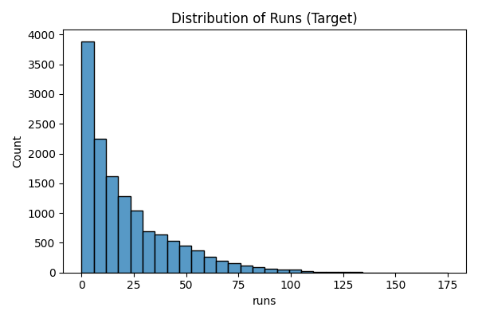
distribution of career average runs
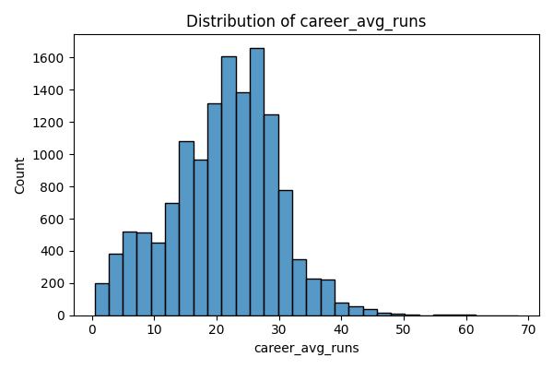
distribution of average runs in last 5 matches
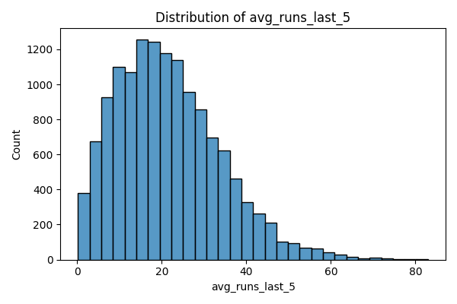
correlation between important features
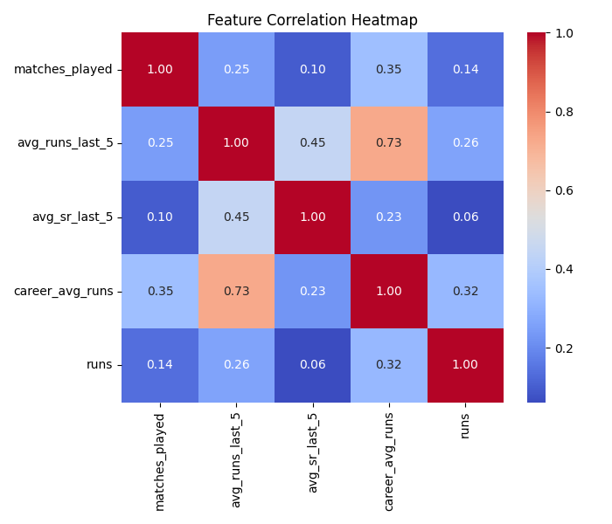
This step helped in validating the usefulness of the engineered features and ensured that they correctly represent player form and consistency.
By analyzing feature distributions and correlations, it was observed that:
recent form features such as average runs in the last few matches have meaningful variation
career average and experience based features show stable trends
no abnormal or unrealistic values were present in the final feature dataset

This analysis helped in confirming that the feature engineering process was successful and the data was suitable for training predictive models.

Week 5 – Model Training and Evaluation
In this week, multiple machine learning models were trained and compared to identify the best performing model for predicting batsman runs.
A simple baseline model was first created using the average of recent matches as a reference predictor. This baseline helps in understanding how much improvement machine learning models provide over simple heuristics.
After that, the following machine learning models were trained:

- Random Forest Regressor
- XGBoost Regressor
- LightGBM Regressor
All models were trained using the same training dataset and evaluated on the same test dataset.
The performance of the models was measured using:
- Root Mean Squared Error (RMSE)
- Mean Absolute Error (MAE)
- R² score

Obtained Results:
Model | RMSE | MAE | R² Score
Baseline (avg_runs_last_5) | 22.91 | 17.22 | -0.035
Random Forest | 22.09 | 16.89 | 0.037
XGBoost | 21.87 | 16.48 | 0.056
LightGBM | 21.87 | 16.49 | 0.056

From the above results, it can be observed that:
- machine learning models clearly outperform the baseline approach
- LightGBM and XGBoost provided the lowest RMSE values
- LightGBM showed slightly better and more stable performance
Based on these results, the LightGBM model was selected as the final prediction model.
The trained models were saved for later use in the dashboard:
- rf_model.pkl
- xgb_model.pkl
- lgb_model.pkl
This week established the final prediction model for the project.

Week 6 – Model Explainability and Validation
In this week, the focus was on understanding how the selected model makes predictions and validating its behavior.
The LightGBM model was loaded and SHAP (SHapley Additive Explanations) was applied to generate feature importance explanations.
SHAP values were computed to:
- identify which features contribute most to the prediction
- explain individual player predictions
- verify whether the model behavior matches cricket domain knowledge
The SHAP visualizations showed that:
- average runs in recent matches
- career average runs
- recent strike rate features
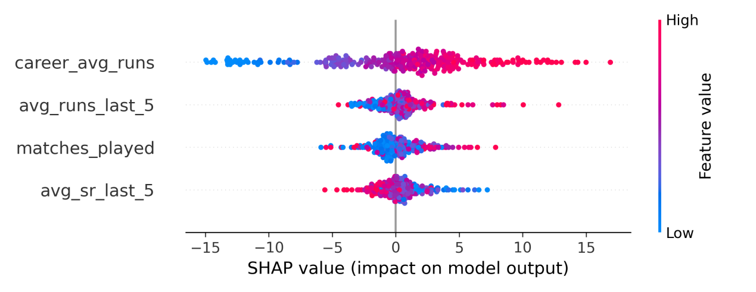

were the most influential features in predicting a batsman’s runs.
This confirmed that the model is primarily learning from meaningful performance indicators rather than irrelevant patterns.
In addition, the trained model and the final feature dataset were validated by performing multiple predictions on different players to verify consistency.
This week ensured that the model is:
- interpretable
- reliable
- suitable for real-world use through a user interface
Week 7 – Integration Preparation and User Interaction Design
In this week, the prediction workflow was prepared for integration into an interactive application.
The following steps were performed:
- loading the trained LightGBM model
- preparing data access logic for player-wise historical records
- designing the input flow for user selection
The input design was finalized in the following order:
- select batsman name
- select opponent team
- select venue
This step ensured that the system can dynamically fetch suitable historical feature rows and perform prediction without requiring users to upload any dataset.
This week mainly focused on preparing a smooth interaction flow between:
- data
- model
- user interface

Week 8 – Dashboard Development and Final System Integration
In the final week, an interactive dashboard was developed using Streamlit.
The dashboard allows the user to:
- select a batsman
- select opponent team
- select venue
- generate predicted runs for the selected scenario
The following components were implemented in the dashboard:
- prediction output
- recent performance visualization
- confidence label based on recent performance variability
- SHAP based explanation plot
- display of model input features
The recent performance graph was plotted using the match order to avoid visual issues caused by repeated season values.
The dashboard successfully integrates:
- data processing
- trained model
- explainability
- visualization
into a single interactive system.
OUTPUT OF THE DASHBOARD
Step1:
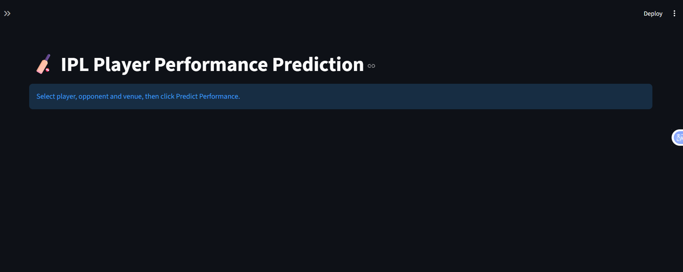

Step2: Select the player,opponent,venue
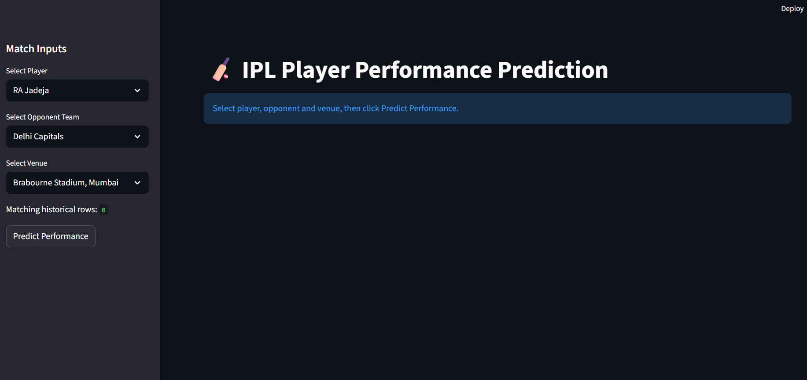
Step3: Predict the performance
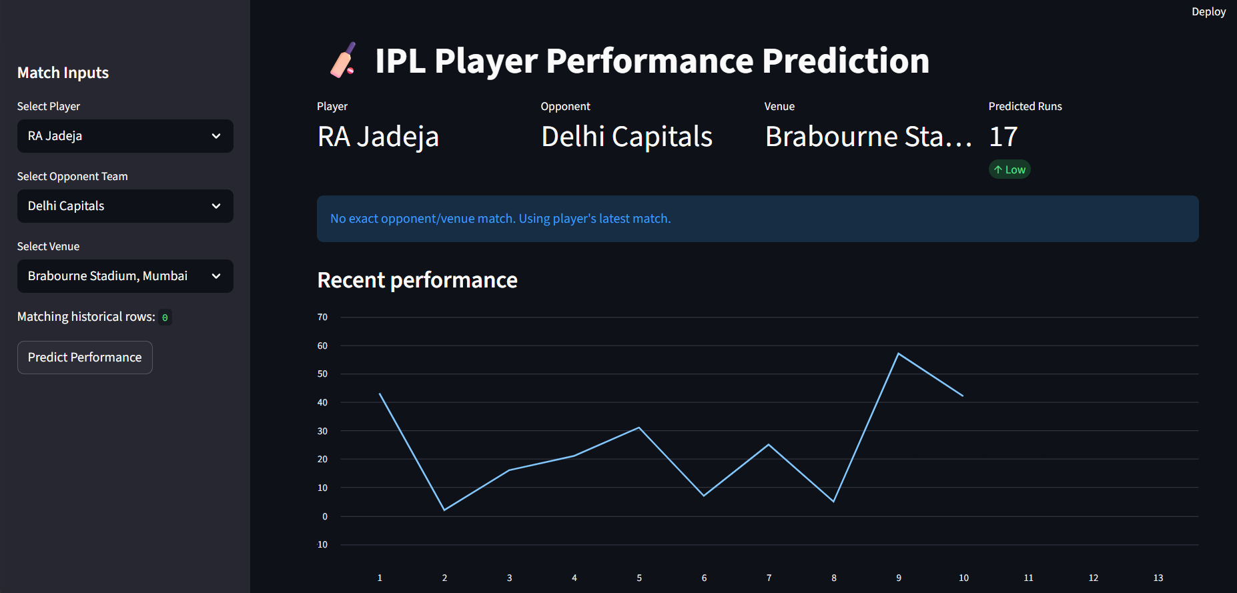
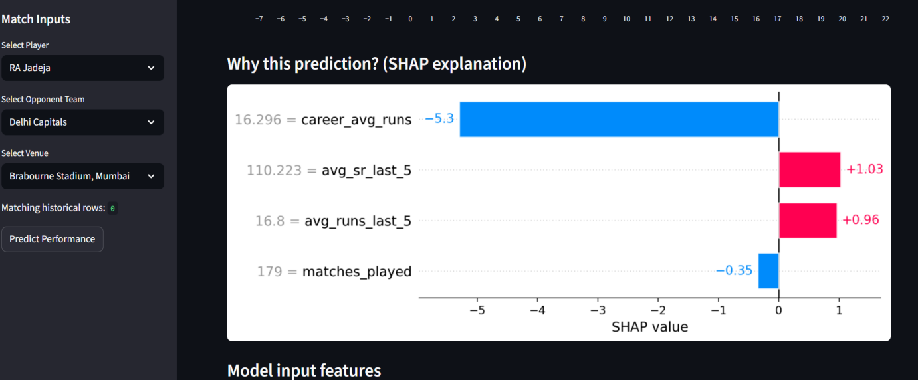
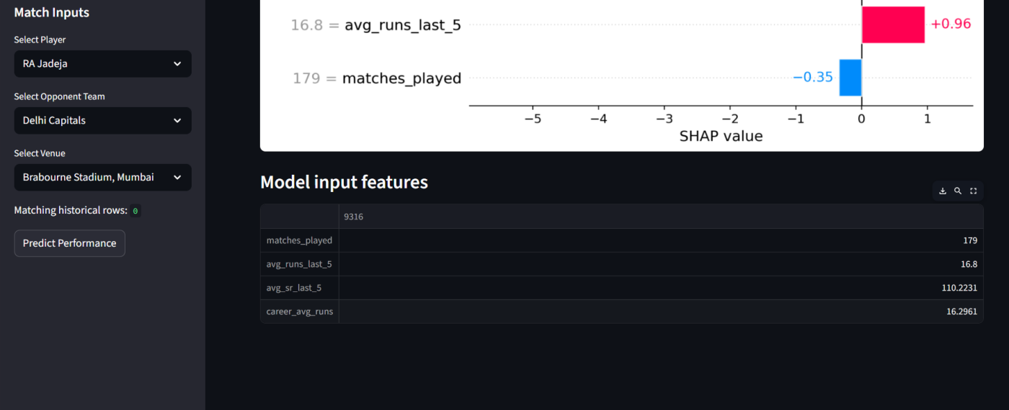

Implementation Tools
The following tools and libraries were used:
- Python
- Pandas and NumPy
- Matplotlib and Seaborn
- Machine learning library (LightGBM / Scikit-learn)
- SHAP
- Streamlit

Results and Discussion
The developed model is able to predict a batsman’s expected runs based on historical performance patterns.
Recent performance features contribute significantly to the prediction results.
The Streamlit dashboard successfully integrates prediction, visualization and explainability into a single user interface.
The use of SHAP improves the interpretability of the model and helps users understand why a particular prediction is generated.

Conclusion
This project successfully demonstrates the application of machine learning techniques for predicting IPL player performance. By converting raw ball-by-ball data into player-level features and applying feature engineering techniques, meaningful performance indicators were obtained. The trained model provides useful predictions and SHAP based explanations enhance the transparency of the system. The developed Streamlit dashboard offers an interactive and user-friendly way to access predictions and visual insights. This project highlights the practical use of data science and machine learning in sports analytics.

References
- Kaggle IPL Dataset
- SHAP Documentation
- Streamlit Documentation
- Scikit-learn / LightGBM Documentation

- LEGA AKSHAYA

This week completes the full machine learning pipeline and converts the developed model into a usable application.

